**OOTs Using Java Workshop**

**Name : Kunwar Shaurya Pratap Singh**

**Course: B.Tech**

**Branch: Computer Science**

**Roll number : 2401330120086**

**Lab : 308B**

**Day 1: Classwork**

**Question:** Write a Java program to print 'Hello World'.

**Solution:**

public class HelloWorld {

public static void main(String[] args) {

System.out.println("Hello World");

}

}

**Output:**

/Users/kunwarshauryapratapsingh/Desktop/OOTSWorkshop/out/production/ClassworkDay1/HelloWorld

Hello World

Process finished with exit code 0

**Question:** Write a Java program to take name and number as input and display them.

**Solution:**

import java.util.Scanner;

public class Name_Number {

public static void main(String[] args) {

Scanner sc = new Scanner(System.in);

System.out.print("Enter name: ");

String a = sc.nextLine();

System.out.print("Enter number: ");

long n = sc.nextLong();

System.out.println("Name: " + a);

System.out.println("Number: " + n);

}

}

**Output:**

/Users/kunwarshauryapratapsingh/Desktop/OOTSWorkshop/out/production/ClassworkDay1/Name_Number

Enter name: Shaurya

Enter number: 1234567890

Name: Shaurya

Number: 1234567890

Process finished with exit code 0

**Question:** Sketch a class diagram containing a class called Employee, which models an employee with an ID, name and salary. Add a method raiseSalary(percent) that increases the salary by the given percentage.

**Solution:**

import java.util.Scanner;

public class SalaryHike {

public static void main(String[] args) {

Scanner sc = new Scanner(System.in);

System.out.println("Salary hike of 10%");

System.out.print("Enter the emp id: ");

int empId = sc.nextInt();

switch (empId) {

case 1:

String name = "Kunal";

int salary = 100000;

double newSalary = hikePercentage(salary) + salary;

System.out.println("EmpName: " + name);

System.out.println("New Salary : " + newSalary);

break;

case 2:

name = "Rohit";

salary = 10000;

newSalary = hikePercentage(salary) + salary;

System.out.println("EmpName: " + name);

System.out.println("New Salary : " + newSalary);

break;

case 3:

name = "Pankaj";

salary = 1000;

newSalary = hikePercentage(salary) + salary;

System.out.println("EmpName: " + name);

System.out.println("New Salary : " + newSalary);

break;

default:

System.out.println("INVALID ID!");

}

}

public static double hikePercentage(int salary) {

double hikeOf = (0.1) * salary;

return hikeOf;

}

}

**Output:**

/Users/kunwarshauryapratapsingh/Desktop/OOTSWorkshop/out/production/ClassworkDay1/SalaryHike

Salary hike of 10%

Enter the emp id: 1

EmpName: Kunal

New Salary : 110000.0

Process finished with exit code 0

**Day 1: Homework**

**Question:** Program to display default value of all Primitive data types.

**Solution:**

public class DefaultValues {

static byte b;

static short s;

static int i;

static long l;

static float f;

static double d;

static char c;

static boolean bool;

public static void main(String[] args) {

System.out.println("Default value of byte: " + b);

System.out.println("Default value of short: " + s);

System.out.println("Default value of int: " + i);

System.out.println("Default value of long: " + l);

System.out.println("Default value of float: " + f);

System.out.println("Default value of double: " + d);

System.out.println("Default value of char: " + c);

System.out.println("Default value of boolean: " + bool);

}

}

**Output:**

/Users/kunwarshauryapratapsingh/Desktop/OOTSWorkshop/out/production/HomeworkDay1/DefaultValues

Default value of byte: 0

Default value of short: 0

Default value of int: 0

Default value of long: 0

Default value of float: 0.0

Default value of double: 0.0

Default value of char:

Default value of boolean: false

Process finished with exit code 0

**Question:** Implement the code using main() method to calculate and print the Total and Average marks scored by a student.

**Solution:**

import java.util.Scanner;

public class AverageCalc {

public static void main(String[] args) {

System.out.print("Enter name: ");

Scanner sc = new Scanner(System.in);

String name = sc.nextLine();

System.out.print("Marks1: ");

int marks1 = sc.nextInt();

System.out.print("Marks2: ");

int marks2 = sc.nextInt();

System.out.print("Marks3: ");

int marks3 = sc.nextInt();

int total = marks1 + marks2 + marks3;

float avg = total / 3;

System.out.println("Total marks are:" + total);

System.out.print("Average is: " + avg);

}

}

**Output:**

/Users/kunwarshauryapratapsingh/Desktop/OOTSWorkshop/out/production/HomeworkDay1/AverageCalc

Enter name: Kunwar Shaurya Pratap Singh

Marks1: 95

Marks2: 92

Marks3: 98

Total marks are:285

Average is: 95.0

Process finished with exit code 0

**Day 2: Classwork**

**Question:** Write code which uses if-then-else statement to check if a given account balance is greater or lesser than the minimum balance.

**Solution:**

import java.util.Scanner;

public class checkBalance {

public static void main(String[] args) {

Scanner sc = new Scanner(System.in);

System.out.println("Enter the balance: ");

int bal = sc.nextInt();

if (bal >= 1000) {

System.out.println("Sufficient balance");

} else {

System.out.println("Balance is low");

}

}

}

**Output:**

/Users/kunwarshauryapratapsingh/Desktop/OOTSWorkshop/out/production/ClassworkDay2/checkBalance

Enter the balance:

500

Balance is low

Process finished with exit code 0

**Question:** A class NumberPalindrome with a public method isNumberPalindrome that takes one parameter number of type int. Write a code to check whether the given number is palindrome or not.

**Solution:**

import java.util.Scanner;

public class NumberPallindrome {

public static void main(String[] args) {

Scanner sc = new Scanner(System.in);

System.out.println("Enter the number: ");

int num = sc.nextInt();

int n = num;

int sum = 0;

while (num > 0) {

int rem = num % 10;

sum = sum * 10 + rem;

num = num / 10;

}

if (sum == n) {

System.out.println("The number is palindrome");

} else {

System.out.println("The number is not a Palindrome");

}

}

}

**Output:**

/Users/kunwarshauryapratapsingh/Desktop/OOTSWorkshop/out/production/ClassworkDay2/NumberPallindrome

Enter the number:

12321

The number is palindrome

Process finished with exit code 0

**Question:** Write a class FibonacciSeries with a main method. The method receives one command line argument. Write a program to display fibonacci series.

**Solution:**

import java.util.Scanner;

public class Fibonacci {

public static void main(String[] args) {

Scanner sc = new Scanner(System.in);

System.out.println("Enter the number of terms: ");

int n = sc.nextInt();

int a = 0;

int b = 1;

int count = 2;

System.out.print(a + " ");

System.out.print(b + " ");

while (count <= n) {

int temp = b;

b = b + a;

a = temp;

count++;

System.out.print(b + " ");

}

}

}

**Output:**

/Users/kunwarshauryapratapsingh/Desktop/OOTSWorkshop/out/production/ClassworkDay2/Fibonacci

Enter the number of terms:

8

0 1 1 2 3 5 8 13

Process finished with exit code 0

**Question:** Write a Java Program to find the Factorial of a given number.

**Solution:**

import java.util.Scanner;

public class factorial {

public static void main(String[] args) {

Scanner sc = new Scanner(System.in);

System.out.println("Enter the number: ");

int num = sc.nextInt();

long fact = 1;

if (num == 0 || num == 1) {

System.out.println("Factorial: 1");

} else {

while (num > 0) {

fact = fact * num;

num--;

}

System.out.println("Factorial: " + fact);

}

}

}

**Output:**

/Users/kunwarshauryapratapsingh/Desktop/OOTSWorkshop/out/production/ClassworkDay2/factorial

Enter the number:

6

Factorial: 720

Process finished with exit code 0

**Day 2: Homework**

**Question:** Java Program to create a class, methods and invoke them inside main method.

**Solution:**

public class invoke { // calling a function is known as invoking

public static void main(String[] args) {

greeting();

morning();

int a = 1;

int b = 2;

add(a, b);

}

public static void greeting() {

System.out.println("Welcome");

}

public static void morning() {

System.out.println("Good Morning Pineapple!");

}

public static void add(int a, int b) {

int c = a + b;

System.out.println(c);

}

}

**Output:**

/Users/kunwarshauryapratapsingh/Desktop/OOTSWorkshop/out/production/HomeWorkDay2/invoke

Welcome

Good Morning Pineapple!

3

Process finished with exit code 0

**Question:** Write a Java program to illustrate the abstract class concept.

**Solution:**

abstract class Shape {

public abstract void numberOfSides();

}

class Trapezoid extends Shape {

@Override

public void numberOfSides() {

System.out.println("A trapezoid has 4 sides.");

}

}

class Triangle extends Shape {

@Override

public void numberOfSides() {

System.out.println("A triangle has 3 sides.");

}

}

class Hexagon extends Shape {

@Override

public void numberOfSides() {

System.out.println("A hexagon has 6 sides.");

}

}

public class AbstractShape {

public static void main(String[] args) {

Shape trapezoid = new Trapezoid();

Shape triangle = new Triangle();

Shape hexagon = new Hexagon();

trapezoid.numberOfSides();

triangle.numberOfSides();

hexagon.numberOfSides();

}

}

**Output:**

/Users/kunwarshauryapratapsingh/Desktop/OOTSWorkshop/out/production/HomeWorkDay2/AbstractShape

A trapezoid has 4 sides.

A triangle has 3 sides.

A hexagon has 6 sides.

Process finished with exit code 0

**Question:** Java program to illustrate the static field in the class.

**Solution:**

class Student {

static String college = "My University";

int studentId;

String name;

Student(int id, String n) {

studentId = id;

name = n;

}

void display() {

System.out.println("ID: " + studentId + ", Name: " + name + ", College: " + college);

}

}

public class StaticField_Illus {

public static void main(String[] args) {

Student s1 = new Student(101, "Alice");

Student s2 = new Student(102, "Bob");

s1.display();

s2.display();

}

}

**Output:**

/Users/kunwarshauryapratapsingh/Desktop/OOTSWorkshop/out/production/HomeWorkDay2/StaticField_Illus

ID: 101, Name: Alice, College: My University

ID: 102, Name: Bob, College: My University

Process finished with exit code 0

**Day 3: Classwork**

**Question:** Write a Java Program to illustrate a static class.

**Solution:**

class University {

    static String universityName = "Global Tech University";

    String establishedYear = "1998";

    static class Department {

        String departmentName;

        public Department(String name) {

            this.departmentName = name;

        }

        public void displayDetails() {

            System.out.println("Department: " + departmentName);

            System.out.println("University: " + universityName);

            // The following line would cause a compile-time error because a static

            // nested class cannot access instance members of the outer class.

            // System.out.println("Established In: " + establishedYear);

        }

    }

}

public class StaticClassDemo {

    public static void main(String[] args) {

        University.Department csDept = new University.Department("Computer Science & Engineering");

csDept.displayDetails();

    }}

**Output:**

Users/kunwarshauryapratapsingh/Desktop/OOTSWorkshop/out/production/ClassWorkDay3/University

Department: Computer Science & Engineering

University: Global Tech University

Process finished with exit code 0

**Question:** Java program to access the class members using super keyword.

**Solution:**

class parent {

String name = "I am Parent Class";

}

class child extends parent {

String name = "I am child class";

void display() {

System.out.println(name);

System.out.println(super.name);

}

}

public class superKeyword {

public static void main(String[] args) {

child c1 = new child();

c1.display();

}

}

**Output:**

/Users/kunwarshauryapratapsingh/Desktop/OOTSWorkshop/out/production/ClassWorkDay3/superKeyword

I am child class

I am Parent Class

Process finished with exit code 0

**Question:** Java program to access the class members using this keyword.

**Solution:**

class Student {

String name;

int age;

Student(String name, int age) {

this.name = name;

this.age = age;

}

void display() {

System.out.println("Name: " + this.name + ", Age: " + this.age);

}

}

public class thisKeyword {

public static void main(String[] args) {

Student S1 = new Student("Xavier", 22);

S1.display();

}

}

**Output:**

/Users/kunwarshauryapratapsingh/Desktop/OOTSWorkshop/out/production/ClassWorkDay3/thisKeyword

Name: Xavier, Age: 22

Process finished with exit code 0

**Question:** Implement an interface named MountainParts that has a constant named TERRAIN that will store the String value "off-road".

**Solution:**

interface MountainParts {

String TERRAIN = "off-road";

void setSuspension(String newValue);

String getSuspension();

void setType(String newValue);

String getType();

}

public class MountainBike implements MountainParts {

private String suspension;

private String type;

public void setSuspension(String newValue) {

suspension = newValue;

}

public String getSuspension() {

return suspension;

}

public void setType(String newValue) {

type = newValue;

}

public String getType() {

return type;

}

public static void main(String[] args) {

MountainBike bike = new MountainBike();

bike.setSuspension("Dual");

bike.setType("Trail");

System.out.println("Terrain: " + MountainParts.TERRAIN);

System.out.println("Suspension: " + bike.getSuspension());

System.out.println("Type: " + bike.getType());

}

}

**Output:**

/Users/kunwarshauryapratapsingh/Desktop/OOTSWorkshop/out/production/ClassWorkDay3/MountainBike

Terrain: off-road

Suspension: Dual

Type: Trail

Process finished with exit code 0

**Day 3: Homework**

**Question:** Java program to demonstrate nested interface inside a interface.

**Solution:**

interface outerinterface {

void outermethod();

interface interinterface {

void innermethod();

}

}

class nestedclass implements outerinterface.interinterface {

public void innermethod() {

System.out.println("inner interface method");

}

}

public class nestedInterface {

public static void main(String[] args) {

outerinterface.interinterface obj1 = new nestedclass();

obj1.innermethod();

}

}

**Output:**

/Users/kunwarshauryapratapsingh/Desktop/OOTSWorkshop/out/production/HomeworkDay3/nestedInterface

inner interface method

Process finished with exit code 0

**Question:** Java program to demonstrate nested interface inside a class.

**Solution:**

class Shape {

// Nested static class

static class TriShape {

void showSides() {

System.out.println("A triangle has three sides");

}

}

}

public class triangle {

public static void main(String[] args) {

Shape.TriShape obj = new Shape.TriShape();

obj.showSides();

}

}

**Output:**

/Users/kunwarshauryapratapsingh/Desktop/OOTSWorkshop/out/production/HomeworkDay3/triangle

A triangle has three sides

Process finished with exit code 0

**Day 4: Classwork**

**Question:** Java program to implement Single Inheritance.

**Solution:**

class Animal1 {

void eat() {

System.out.println("This animal eats food");

}

}

class Dog1 extends Animal1 {

void bark() {

System.out.println("Dogs Barks");

}

}

public class Single_Inheritance {

public static void main(String[] args) {

Dog1 d = new Dog1();

d.bark();

d.eat();

}

}

**Output:**

/Users/kunwarshauryapratapsingh/Desktop/OOTSWorkshop/out/production/ClassworkDay4/Single_Inheritance

Dogs Barks

This animal eats food

Process finished with exit code 0

**Question:** Java program to implement multi-level inheritance.

**Solution:**

class Vehicle1 {

void start() {

System.out.println("Vehicle is starting...");

}

}

class Car1 extends Vehicle1 {

void drive() {

System.out.println("Car is moving");

}

}

class ElectricCar extends Car1 {

void charge() {

System.out.println("Electric car is charging.");

}

}

public class multilvl_inheritence {

public static void main(String[] args) {

ElectricCar myEv = new ElectricCar();

myEv.start();

myEv.drive();

myEv.charge();

}

}

**Output:**

/Users/kunwarshauryapratapsingh/Desktop/OOTSWorkshop/out/production/ClassworkDay4/multilvl_inheritence

Vehicle is starting...

Car is moving

Electric car is charging.

Process finished with exit code 0

**Question:** Java program to implement constructor and constructor overloading.

**Solution:**

class Box {

double width, height, depth;

Box(double w, double h, double d) {

width = w;

height = h;

depth = d;

}

Box() {

width = height = depth = 0;

}

Box(double len) {

width = height = depth = len;

}

double volume() {

return width * height * depth;

}

}

public class ConstructorOverloading {

public static void main(String args[]) {

Box mybox1 = new Box(10, 20, 15);

Box mybox2 = new Box();

Box mycube = new Box(7);

System.out.println("Volume of mybox1 is " + mybox1.volume());

System.out.println("Volume of mybox2 is " + mybox2.volume());

System.out.println("Volume of mycube is " + mycube.volume());

}

}

**Output:**

/Users/kunwarshauryapratapsingh/Desktop/OOTSWorkshop/out/production/ClassworkDay4/ConstructorOverloading

Volume of mybox1 is 3000.0

Volume of mybox2 is 0.0

Volume of mycube is 343.0

Process finished with exit code 0

**Question:** Java program to implement method overloading.

**Solution:**

class Calculator {

int add(int a, int b) { return a + b; }

int add(int a, int b, int c) { return a + b + c; }

double add(double a, double b) { return a + b; }

}

public class MethodOverloadingEx {

public static void main(String[] args) {

Calculator calc = new Calculator();

System.out.println("Sum of 2 and 3 is: " + calc.add(2, 3));

System.out.println("Sum of 2, 3, and 4 is: " + calc.add(2, 3, 4));

System.out.println("Sum of 2.5 and 3.5 is: " + calc.add(2.5, 3.5));

}

}

**Output:**

/Users/kunwarshauryapratapsingh/Desktop/OOTSWorkshop/out/production/ClassworkDay4/MethodOverloadingEx

Sum of 2 and 3 is: 5

Sum of 2, 3, and 4 is: 9

Sum of 2.5 and 3.5 is: 6.0

Process finished with exit code 0

**Question:** Java program to implement method overriding.

**Solution:**

class Vehicle2 {

void run() {

System.out.println("Vehicle is running");

}

}

class Car2 extends Vehicle2 {

void run() {

System.out.println("Car is running safely");

}

}

public class overriding_example {

public static void main(String args[]) {

Car2 obj = new Car2();

obj.run();

}

}

**Output:**

/Users/kunwarshauryapratapsingh/Desktop/OOTSWorkshop/out/production/ClassworkDay4/overriding_example

Car is running safely

Process finished with exit code 0

**Day 5: Classwork**

**Question:** Java program to implement lambda expression without parameter.

**Solution:**

interface MyFunctionalInterface {

String sayHello();

}

public class LambdaNoParams {

public static void main(String[] args) {

MyFunctionalInterface msg = () -> "Hello, World!";

System.out.println(msg.sayHello());

}

}

**Output:**

/Users/kunwarshauryapratapsingh/Desktop/OOTSWorkshop/out/production/ClassworkDay5/LambdaNoParams

Hello, World!

Process finished with exit code 0

**Question:** Java program to implement lambda expression with single parameter.

**Solution:**

interface FuncInterface {

void abstractfun(int x);

default void normal() {

System.out.println("Hello");

}

}

public class LambdaSingleParam {

public static void main(String[] args) {

FuncInterface fobj = (int x) -> System.out.println(2 * x);

fobj.abstractfun(5);

fobj.normal();

}

}

**Output:**

/Users/kunwarshauryapratapsingh/Desktop/OOTSWorkshop/out/production/ClassworkDay5/LambdaSingleParam

10

Hello

Process finished with exit code 0

**Question:** Java program to define lambda expressions as method parameters.

**Solution:**

import java.util.function.Consumer;

public class LambdaAsMethodParameter {

public static void processString(String str, Consumer<String> processor) {

processor.accept(str);

}

public static void main(String[] args) {

String greeting = "Hello Lambda!";

processString(greeting, (s) -> System.out.println("Printing: " + s));

processString(greeting, (s) -> System.out.println("Length: " + s.length()));

}

}

**Output:**

/Users/kunwarshauryapratapsingh/Desktop/OOTSWorkshop/out/production/ClassworkDay5/LambdaAsMethodParameter

Printing: Hello Lambda!

Length: 13

Process finished with exit code 0

**Question:** Write a class CountOfTwoNumbers with a public method compareCountOf that takes three parameters and returns true if count of arg1 is greater than arg2 in arr.

**Solution:**

public class CountOfTwoNumbers {

public boolean compareCountOf(int[] arr, int arg1, int arg2) {

int count1 = 0;

int count2 = 0;

for (int num : arr) {

if (num == arg1) count1++;

if (num == arg2) count2++;

}

return count1 > count2;

}

public static void main(String[] args) {

CountOfTwoNumbers counter = new CountOfTwoNumbers();

int[] sampleArray = { 1, 2, 3, 1, 1, 4, 5, 2, 1 };

int num1 = 1;

int num2 = 2;

boolean result = counter.compareCountOf(sampleArray, num1, num2);

System.out.println("Is the count of " + num1 + " greater than the count of " + num2 + "? " + result);

}

}

**Output:**

/Users/kunwarshauryapratapsingh/Desktop/OOTSWorkshop/out/production/ClassworkDay5/CountOfTwoNumbers

Is the count of 1 greater than the count of 2? true

Process finished with exit code 0

**Question:** Java program to show the multiplication of two matrices using arrays.

**Solution:**

public class MatrixMultiplication {

public static void main(String[] args) {

int[][] firstMatrix = { { 3, -2, 5 }, { 3, 0, 4 } };

int[][] secondMatrix = { { 2, 3 }, { -9, 0 }, { 0, 4 } };

int[][] product = new int[firstMatrix.length][secondMatrix[0].length];

for (int i = 0; i < firstMatrix.length; i++) {

for (int j = 0; j < secondMatrix[0].length; j++) {

for (int k = 0; k < firstMatrix[0].length; k++) {

product[i][j] += firstMatrix[i][k] * secondMatrix[k][j];

}

}

}

System.out.println("Product of the matrices is:");

for (int[] row : product) {

for (int column : row) {

System.out.print(column + " ");

}

System.out.println();

}

}

}

**Output:**

/Users/kunwarshauryapratapsingh/Desktop/OOTSWorkshop/out/production/ClassworkDay5/MatrixMultiplication

Product of the matrices is:

24 29

6 25

Process finished with exit code 0

**Question:** Java Program to search an element using Linear Search.

**Solution:**

import java.util.Scanner;

public class linear_Searching {

public static void main(String[] args) {

Scanner sc = new Scanner(System.in);

int[] arr = {10, 20, 30, 40, 50};

System.out.println("Array: 10 20 30 40 50");

System.out.print("Enter the target value: ");

int target = sc.nextInt();

int result = linear(arr, target);

if(result != -1)

System.out.println("Element found at index: " + result);

else

System.out.println("Element not found in the array.");

}

static int linear(int[] arr, int target) {

for (int i = 0; i < arr.length; i++) {

if (arr[i] == target) return i;

}

return -1;

}

}

**Output:**

/Users/kunwarshauryapratapsingh/Desktop/OOTSWorkshop/out/production/ClassworkDay5/linear_Searching

Array: 10 20 30 40 50

Enter the target value: 30

Element found at index: 2

Process finished with exit code 0

**Question:** Java program to search an element using Binary Search.

**Solution:**

import java.util.Scanner;

import java.util.Arrays;

public class binary_Searching {

public static void main(String[] args) {

Scanner sc = new Scanner(System.in);

int[] arr = {2, 5, 8, 12, 16, 23, 38, 56, 72, 91};

System.out.println("Sorted Array: " + Arrays.toString(arr));

System.out.print("Enter the target value: ");

int target = sc.nextInt();

int res = binary(arr, target);

if (res == -1) {

System.out.println("The target doesn't exist.");

} else

System.out.println("Target found at index: " + res);

}

static int binary(int[] arr, int target) {

int start = 0, end = arr.length - 1;

while (start <= end) {

int mid = start + (end - start) / 2;

if (target < arr[mid]) end = mid - 1;

else if (target > arr[mid]) start = mid + 1;

else return mid;

}

return -1;

}

}

**Output:**

/Users/kunwarshauryapratapsingh/Desktop/OOTSWorkshop/out/production/ClassworkDay5/binary_Searching

Sorted Array: [2, 5, 8, 12, 16, 23, 38, 56, 72, 91]

Enter the target value: 23

Target found at index: 5

Process finished with exit code 0

**Day 5: Homework**

**Question:** Java program to implement lambda expression with multi parameter.

**Solution:**

interface StringConcat {

String concat(String a, String b);

}

public class LambdaMultiParams {

public static void main(String[] args) {

StringConcat sc = (str1, str2) -> str1 + str2;

System.out.println("Result: " + sc.concat("Hello ", "World"));

}

}

**Output:**

/Users/kunwarshauryapratapsingh/Desktop/OOTSWorkshop/out/production/HomeWorkDay5/LambdaMultiParams

Result: Hello World

Process finished with exit code 0

**Question:** Java program to implement lambda expression that iterate list of objects.

**Solution:**

import java.util.ArrayList;

import java.util.List;

public class LambdaList {

public static void main(String[] args) {

List<String> fruits = new ArrayList<>();

fruits.add("Apple");

fruits.add("Banana");

fruits.add("Cherry");

fruits.add("Date");

System.out.println("Printing list elements:");

fruits.forEach(System.out::println);

}

}

**Output:**

/Users/kunwarshauryapratapsingh/Desktop/OOTSWorkshop/out/production/HomeWorkDay5/LambdaList

Printing list elements:

Apple

Banana

Cherry

Date

Process finished with exit code 0

**Question:** Java Program to sort element using insertion Sort.

**Solution:**

import java.util.Arrays;

public class insertion_Sort {

public static void sort(int[] arr) {

for (int i = 1; i < arr.length; i++) {

int key = arr[i];

int j = i - 1;

while (j >= 0 && arr[j] > key) {

arr[j + 1] = arr[j];

j = j - 1;

}

arr[j + 1] = key;

}

}

public static void main(String[] args) {

int[] data = { 9, 5, 1, 4, 3 };

System.out.println("Unsorted Array: " + Arrays.toString(data));

sort(data);

System.out.println("Sorted Array : " + Arrays.toString(data));

}

}

**Output:**

/Users/kunwarshauryapratapsingh/Desktop/OOTSWorkshop/out/production/HomeWorkDay5/insertion_Sort

Unsorted Array: [9, 5, 1, 4, 3]

Sorted Array : [1, 3, 4, 5, 9]

Process finished with exit code 0

**Question:** Java Program to sort element using Selection Sort.

**Solution:**

import java.util.Arrays;

public class SelectionSort {

public static void sort(int[] arr) {

for (int i = 0; i < arr.length - 1; i++) {

int minIndex = i;

for (int j = i + 1; j < arr.length; j++) {

if (arr[j] < arr[minIndex]) {

minIndex = j;

}

}

int temp = arr[minIndex];

arr[minIndex] = arr[i];

arr[i] = temp;

}

}

public static void main(String[] args) {

int[] data = { 20, 12, 10, 15, 2 };

System.out.println("Unsorted Array: " + Arrays.toString(data));

sort(data);

System.out.println("Sorted Array : " + Arrays.toString(data));

}

}

**Output:**

/Users/kunwarshauryapratapsingh/Desktop/OOTSWorkshop/out/production/HomeWorkDay5/SelectionSort

Unsorted Array: [20, 12, 10, 15, 2]

Sorted Array : [2, 10, 12, 15, 20]

Process finished with exit code 0

**Question:** Java program to Sort elements using Bubble Sort.

**Solution:**

import java.util.Arrays;

public class BubbleSort {

public static void main(String[] args) {

int[] arr = { 64, 34, 25, 12, 22, 11, 90 };

System.out.println("Unsorted array: " + Arrays.toString(arr));

bubble(arr);

System.out.println("Sorted array: " + Arrays.toString(arr));

}

static void bubble(int[] arr) {

boolean swapped;

for (int i = 0; i < arr.length - 1; i++) {

swapped = false;

for (int j = 0; j < arr.length - i - 1; j++) {

if (arr[j] > arr[j + 1]) {

int temp = arr[j];

arr[j] = arr[j + 1];

arr[j + 1] = temp;

swapped = true;

}

}

if (!swapped) break;

}

}

}

**Output:**

/Users/kunwarshauryapratapsingh/Desktop/OOTSWorkshop/out/production/HomeWorkDay5/BubbleSort

Unsorted array: [64, 34, 25, 12, 22, 11, 90]

Sorted array: [11, 12, 22, 25, 34, 64, 90]

Process finished with exit code 0

**Day 7: Classwork**

**Question:** Java program to create user defined package.

**Solution:** *File 1: greetings.java (inside com/shaurya package)*

package com.shaurya;

public class greetings {

public void displayMessage() {

System.out.println("Hello from the 'shaurya' package!");

}

}

*File 2: Main.java (inside com package)*

package com;

import com.shaurya.greetings;

public class Main {

public static void main(String[] args) {

greetings hello = new greetings();

hello.displayMessage();

}

}

**Output:**

/Users/kunwarshauryapratapsingh/Desktop/OOTSWorkshop/out/production/ClassWorkDay7/com/Main

Hello from the 'shaurya' package!

Process finished with exit code 0

**Question:** Implement and demonstrate package names collision in java.

**Solution:**

import java.util.*;

import java.awt.*;

public class collison {

public static void main(String[] args) {

// Using fully qualified name to avoid ambiguity

java.util.List<String> stringList = new ArrayList<>();

stringList.add("No collision here!");

java.awt.List awtList = new java.awt.List();

awtList.add("This one is fine too.");

System.out.println(stringList.get(0));

System.out.println(awtList.getItem(0));

}

}

**Output:**

/Users/kunwarshauryapratapsingh/Desktop/OOTSWorkshop/out/production/ClassWorkDay7/collison

No collision here!

This one is fine too.

Process finished with exit code 0

**Question:** Java program to handle an Arithmetic Exception Divided by zero.

**Solution:**

public class ArithmeticExceptionDemo {

public static void main(String[] args) {

try {

int a = 30;

int b = 0;

int c = a / b;

System.out.println("Result: " + c);

} catch (ArithmeticException e) {

System.out.println("Caught an exception: Cannot divide by zero.");

}

System.out.println("Program continues after the exception.");

}

}

**Output:**

/Users/kunwarshauryapratapsingh/Desktop/OOTSWorkshop/out/production/ClassWorkDay7/ArithmeticExceptionDemo

Caught an exception: Cannot divide by zero.

Program continues after the exception.

Process finished with exit code 0

**Question:** Java Program to implement User Defined Exception.

**Solution:**

class InsufficientFundsException extends Exception {

public InsufficientFundsException(String message) {

super(message);

}

}

class BankAccount {

private double balance;

public BankAccount(double initialBalance) {

this.balance = initialBalance;

}

public void withdraw(double amount) throws InsufficientFundsException {

if (amount > balance) {

throw new InsufficientFundsException("Withdrawal amount exceeds balance.");

}

balance -= amount;

System.out.println("Withdrawal successful. New balance: " + balance);

}

}

public class UserDefinedException {

public static void main(String[] args) {

BankAccount account = new BankAccount(1000);

try {

account.withdraw(500);

account.withdraw(600);

} catch (InsufficientFundsException e) {

System.err.println("Error: " + e.getMessage());

}

}

}

**Output:**

/Users/kunwarshauryapratapsingh/Desktop/OOTSWorkshop/out/production/ClassWorkDay7/UserDefinedException

Withdrawal successful. New balance: 500.0

Error: Withdrawal amount exceeds balance.

Process finished with exit code 0

**Day 7: Homework**

**Question:** Java program to illustrate finally block.

**Solution:**

public class FinallyBlockEx {

public static void main(String[] args) {

try {

System.out.println("Inside the try block.");

int result = 10 / 0;

System.out.println("This line will not be executed.");

} catch (ArithmeticException e) {

System.out.println("Caught ArithmeticException.");

} finally {

System.out.println("Inside the finally block. This always runs!");

}

System.out.println("Program continues...");

}

}

**Output:**

/Users/kunwarshauryapratapsingh/Desktop/OOTSWorkshop/out/production/HomeworkDay7/FinallyBlockEx

Inside the try block.

Caught ArithmeticException.

Inside the finally block. This always runs!

Program continues...

Process finished with exit code 0

**Question:** Java program to illustrate Multiple catch blocks.

**Solution:**

public class MultiCatch {

public static void main(String[] args) {

try {

int[] a = new int[5];

a[5] = 30 / 0; // This will cause ArithmeticException first

} catch (ArithmeticException e) {

System.out.println("Caught an ArithmeticException: Division by zero.");

} catch (ArrayIndexOutOfBoundsException e) {

System.out.println("Caught an ArrayIndexOutOfBoundsException.");

} catch (Exception e) {

System.out.println("Caught a general exception.");

}

}

}

**Output:**

/Users/kunwarshauryapratapsingh/Desktop/OOTSWorkshop/out/production/HomeworkDay7/MultiCatch

Caught an ArithmeticException: Division by zero.

Process finished with exit code 0

**Question:** Java program for creation of illustrating throw in exception handling.

**Solution:**

public class ExceptionHandling {

public static void validateAge(int age) {

if (age < 18) {

throw new ArithmeticException("Person is not eligible to vote.");

} else {

System.out.println("Person is eligible to vote.");

}

}

public static void main(String[] args) {

try {

validateAge(13);

} catch (ArithmeticException e) {

System.out.println("Exception caught: " + e.getMessage());

}

System.out.println("Program continues...");

}

}

**Output:**

/Users/kunwarshauryapratapsingh/Desktop/OOTSWorkshop/out/production/HomeworkDay7/ExceptionHandling

Exception caught: Person is not eligible to vote.

Program continues...

Process finished with exit code 0

**Question:** Implement the concept of Assertion in Java Programming Language.

**Solution:**

import java.util.Scanner;

public class Assertion_illus {

public static void main(String[] args) {

Scanner scanner = new Scanner(System.in);

System.out.print("Enter a number between 0 and 10: ");

int value = scanner.nextInt();

// To run this, you need to enable assertions with the -ea flag

// Example: java -ea Assertion_illus

assert (value >= 0 && value <= 10) : "The number is not within the valid range!";

System.out.println("You entered: " + value);

scanner.close();

}

}

**Output (with assertions enabled and invalid input):**

/Users/kunwarshauryapratapsingh/Desktop/OOTSWorkshop/out/production/HomeworkDay7/Assertion_illus

Enter a number between 0 and 10: 15

Exception in thread "main" java.lang.AssertionError: The number is not within the valid range!

at Assertion_illus.main(Assertion_illus.java:10)

Process finished with exit code 1

**Day 8: Classwork**

**Question:** Implement the concept of Localization in Java Programming Language.

**Solution:**

import java.util.*;

public class LocalizationExample {

public static void main(String[] args) {

// Note: Requires Messages_fr.properties and Messages_hi.properties files

Locale french = new Locale("fr");

Locale hindi = new Locale("hi");

Locale defaultLocale = new Locale("en");

printMessage(french);

printMessage(hindi);

printMessage(defaultLocale);

}

public static void printMessage(Locale locale) {

ResourceBundle bundle = ResourceBundle.getBundle("Messages", locale);

System.out.println(locale.getDisplayLanguage() + ": " + bundle.getString("greeting"));

}

}

**Output:**

/Users/kunwarshauryapratapsingh/Desktop/OOTSWorkshop/out/production/ClassWorkDay8/LocalizationExample

French: Bonjour

Hindi: नमस्ते

English: Hello

Process finished with exit code 0

**Question:** Java program to print the output by appending all the capital letters in the input string.

**Solution:**

public class StringHandling {

public static void main(String[] args) {

String input = "Hello World, This Is JAVA";

StringBuilder capitals = new StringBuilder();

for (char c : input.toCharArray()) {

if (Character.isUpperCase(c)) {

capitals.append(c);

}

}

System.out.println("Original String: " + input);

System.out.println("Capital letters: " + capitals.toString());

}

}

**Output:**

/Users/kunwarshauryapratapsingh/Desktop/OOTSWorkshop/out/production/ClassWorkDay8/StringHandling

Original String: Hello World, This Is JAVA

Capital letters: HWTIJAVA

Process finished with exit code 0

**Question:** Java program that prints the duplicate characters from the string with its count.

**Solution:**

public class DuplicateCharCount {

public static void main(String[] args) {

String s1 = "Beautiful";

System.out.println("The String is: " + s1);

System.out.print("The Duplicate characters in a string: ");

char[] string = s1.toCharArray();

int count;

for(int i = 0; i <string.length; i++) {

count = 1;

for(int j = i+1; j <string.length; j++) {

if(string[i] == string[j] && string[i] != ' ') {

count++;

//Set string[j] to 0 to avoid printing visited character

string[j] = '0';

}

}

//A character is considered as duplicate if count is greater than 1

if(count > 1 && string[i] != '0')

System.out.println(string[i] + ", count = " + count);

}

}

}

**Output:**

/Users/kunwarshauryapratapsingh/Desktop/OOTSWorkshop/out/production/ClassWorkDay8/DuplicateCharCount

The String is: Beautiful

The Duplicate characters in a string: u, count = 2

Process finished with exit code 0

**Question:** Java program to check if two strings are anagrams of each other.

**Solution:**

import java.util.Arrays;

import java.util.Scanner;

public class anagram {

public static void main(String[] args) {

Scanner sc = new Scanner(System.in);

System.out.print("Enter first string: ");

String str1 = sc.nextLine();

System.out.print("Enter second string: ");

String str2 = sc.nextLine();

str1 = str1.replaceAll("\\s", "").toLowerCase();

str2 = str2.replaceAll("\\s", "").toLowerCase();

if (str1.length() != str2.length()) {

System.out.println("Not Anagrams");

return;

}

char[] charArray1 = str1.toCharArray();

char[] charArray2 = str2.toCharArray();

Arrays.sort(charArray1);

Arrays.sort(charArray2);

if (Arrays.equals(charArray1, charArray2)) {

System.out.println("Strings are anagrams");

} else {

System.out.println("Not Anagrams");

}

sc.close();

}

}

**Output:**

/Users/kunwarshauryapratapsingh/Desktop/OOTSWorkshop/out/production/ClassWorkDay8/anagram

Enter first string: Listen

Enter second string: Silent

Strings are anagrams

Process finished with exit code 0

**Day 8: Homework**

**Question:** Java Program to count the total number of characters in a string.

**Solution:**

public class string_length {

public static void main(String[] args) {

String a = "Hello World";

int length = a.length();

System.out.println("The length of the string is: " + length);

}

}

**Output:**

/Users/kunwarshauryapratapsingh/Desktop/OOTSWorkshop/out/production/HomeWorkDay8/string_length

The length of the string is: 11

Process finished with exit code 0

**Question:** Java Program to count the total number of punctuation characters exists in a String.

**Solution:**

public class punctuation_Count {

public static void main(String[] args) {

String p = "Hello! This is a Ball. How are you?";

int count = 0;

for (int i = 0; i < p.length(); i++) {

char ch = p.charAt(i);

if (ch == '!' || ch == ',' || ch == ';' || ch == '.' || ch == '?' || ch == '\'' || ch == '\"' || ch == ':') {

count++;

}

}

System.out.println("The number of punctuations exists in the string is: " + count);

}

}

**Output:**

/Users/kunwarshauryapratapsingh/Desktop/OOTSWorkshop/out/production/HomeWorkDay8/punctuation_Count

The number of punctuations exists in the string is: 3

Process finished with exit code 0

**Day 9: Classwork**

**Question:** Java Program to count the total number of vowels and consonants in a string.

**Solution:**

import java.util.Scanner;

public class vowel_ConsoCount {

public static void main(String[] args) {

Scanner sc = new Scanner(System.in);

System.out.print("Enter a string: ");

String str = sc.nextLine().toLowerCase();

int vowels = 0, consonants = 0;

for (int i = 0; i < str.length(); i++) {

char ch = str.charAt(i);

if (ch >= 'a' && ch <= 'z') {

if (ch == 'a' || ch == 'e' || ch == 'i' || ch == 'o' || ch == 'u') {

vowels++;

} else {

consonants++;

}

}

}

System.out.println("Vowels: " + vowels);

System.out.println("Consonants: " + consonants);

}

}

**Output:**

/Users/kunwarshauryapratapsingh/Desktop/OOTSWorkshop/out/production/ClassWorkDay9/vowel_ConsoCount

Enter a string: HelloWorld

Vowels: 3

Consonants: 7

Process finished with exit code 0

**Question:** Java Program to show equals method and == operator in java.

**Solution:**

public class EqualsVsEqualsOperator {

public static void main(String[] args) {

String s1 = "Hello";

String s2 = "Hello";

String s3 = new String("Hello");

System.out.println("Comparing s1 and s2 (from string pool):");

System.out.println("s1 == s2: " + (s1 == s2));

System.out.println("s1.equals(s2): " + s1.equals(s2));

System.out.println("\nComparing s1 and s3 (pool vs. heap):");

System.out.println("s1 == s3: " + (s1 == s3));

System.out.println("s1.equals(s3): " + s1.equals(s3));

}

}

**Output:**

/Users/kunwarshauryapratapsingh/Desktop/OOTSWorkshop/out/production/ClassWorkDay9/EqualsVsEqualsOperator

Comparing s1 and s2 (from string pool):

s1 == s2: true

s1.equals(s2): true

Comparing s1 and s3 (pool vs. heap):

s1 == s3: false

s1.equals(s3): true

Process finished with exit code 0

**Question:** Given a string, return a new string made of n copies of the first 2 chars of the original string where n is the length of the string.

**Solution:**

public class nCopiesOfFirstTwoChar {

public static String nFirstTwo(String str) {

int n = str.length();

String firstTwo = (n < 2) ? str : str.substring(0, 2);

StringBuilder result = new StringBuilder();

for (int i = 0; i < n; i++) {

result.append(firstTwo);

}

return result.toString();

}

public static void main(String[] args) {

String input1 = "Wipped";

System.out.println("Input: \"" + input1 + "\" -> Output: \"" + nFirstTwo(input1) + "\"");

}

}

**Output:**

/Users/kunwarshauryapratapsingh/Desktop/OOTSWorkshop/out/production/ClassWorkDay9/nCopiesOfFirstTwoChar

Input: "Wipped" -> Output: "WiWiWiWiWiWi"

Process finished with exit code 0

**Question:** Given two strings, a and b, create a bigger string made of the first char of a, the first char of b, the second char of a, the second char of b, and so on.

**Solution:**

public class MixStrings {

public static String mix(String a, String b) {

StringBuilder result = new StringBuilder();

int lenA = a.length();

int lenB = b.length();

int minLength = Math.min(lenA, lenB);

for (int i = 0; i < minLength; i++) {

result.append(a.charAt(i));

result.append(b.charAt(i));

}

if (lenA > lenB) result.append(a.substring(minLength));

else if (lenB > lenA) result.append(b.substring(minLength));

return result.toString();

}

public static void main(String[] args) {

String a = "Hello";

String b = "World";

System.out.println("Mixing \"" + a + "\" and \"" + b + "\" -> \"" + mix(a, b) + "\"");

}

}

**Output:**

/Users/kunwarshauryapratapsingh/Desktop/OOTSWorkshop/out/production/ClassWorkDay9/MixStrings

Mixing "Hello" and "World" -> "HWeolrllod"

Process finished with exit code 0

**Day 9: Homework**

**Question:** Java program to show the usage of string builder.

**Solution:**

public class String_builder {

public static void main(String[] args) {

StringBuilder sb = new StringBuilder("Hello");

System.out.println("Original: " + sb);

sb.append(" World");

System.out.println("After append: " + sb);

sb.insert(6, "Java ");

System.out.println("After insert: " + sb);

sb.replace(0, 5, "Greetings");

System.out.println("After replace: " + sb);

sb.delete(10, 15);

System.out.println("After delete: " + sb);

sb.reverse();

System.out.println("After reverse: " + sb);

}

}

**Output:**

/Users/kunwarshauryapratapsingh/Desktop/OOTSWorkshop/out/production/HomeWorkDay9/String_builder

Original: Hello

After append: Hello World

After insert: Hello Java World

After replace: Greetings Java World

After delete: Greetings Java W

After reverse: W avaJ sgniteerG

Process finished with exit code 0

**Question:** Java program to show the usage of string buffer.

**Solution:**

public class String_Buffer {

public static void main(String[] args) {

StringBuffer sbf = new StringBuffer("Test");

System.out.println("Original: " + sbf);

sbf.append("ing");

System.out.println("After append: " + sbf);

sbf.reverse();

System.out.println("After reverse: " + sbf);

}

}

**Output:**

/Users/kunwarshauryapratapsingh/Desktop/OOTSWorkshop/out/production/HomeWorkDay9/String_Buffer

Original: Test

After append: Testing

After reverse: gnitseT

Process finished with exit code 0

**Day 10: Classwork**

**Question:** Creating and Running a Thread.

**Solution:**

public class MyThread extends Thread {

@Override

public void run() {

System.out.println("This code is running in a thread");

}

public static void main(String[] args) {

MyThread thread = new MyThread();

thread.start();

System.out.println("This code is outside of thread");

}

}

**Output:**

/Users/kunwarshauryapratapsingh/Desktop/OOTSWorkshop/out/production/ClassWorkDay10/MyThread

This code is outside of thread

This code is running in a thread

Process finished with exit code 0

**Question:** Implementing Runnable Interface.

**Solution:**

class RunnableDemo implements Runnable {

private String threadName;

RunnableDemo(String name) {

threadName = name;

System.out.println("Creating " + threadName);

}

public void run() {

System.out.println("Running " + threadName);

try {

for (int i = 4; i > 0; i--) {

System.out.println("Thread: " + threadName + ", " + i);

Thread.sleep(50);

}

} catch (InterruptedException e) {

System.out.println("Thread " + threadName + " interrupted.");

}

System.out.println("Thread " + threadName + " exiting.");

}

}

public class custThread {

public static void main(String args[]) {

RunnableDemo R1 = new RunnableDemo("Thread-1");

new Thread(R1).start();

RunnableDemo R2 = new RunnableDemo("Thread-2");

new Thread(R2).start();

}

}

**Output:**

/Users/kunwarshauryapratapsingh/Desktop/OOTSWorkshop/out/production/ClassWorkDay10/custThread

Creating Thread-1

Creating Thread-2

Running Thread-1

Thread: Thread-1, 4

Running Thread-2

Thread: Thread-2, 4

Thread: Thread-1, 3

Thread: Thread-2, 3

Thread: Thread-1, 2

Thread: Thread-2, 2

Thread: Thread-1, 1

Thread: Thread-2, 1

Thread Thread-1 exiting.

Thread Thread-2 exiting.

Process finished with exit code 0

**Question:** Synchronizing Threads with and without lock.

**Solution:**

class Counter {

private int count = 0;

public synchronized void incrementWithLock() { count++; }

public void incrementWithoutLock() { count++; }

public int getCount() { return count; }

}

public class SyncThreadWithWithoutLock {

public static void main(String[] args) throws InterruptedException {

Counter counter = new Counter();

Thread t1 = new Thread(() -> { for (int i = 0; i < 1000; i++) counter.incrementWithoutLock(); });

Thread t2 = new Thread(() -> { for (int i = 0; i < 1000; i++) counter.incrementWithoutLock(); });

t1.start(); t2.start();

t1.join(); t2.join();

System.out.println("Final count without lock: " + counter.getCount());

Counter safeCounter = new Counter();

Thread t3 = new Thread(() -> { for (int i = 0; i < 1000; i++) safeCounter.incrementWithLock(); });

Thread t4 = new Thread(() -> { for (int i = 0; i < 1000; i++) safeCounter.incrementWithLock(); });

t3.start(); t4.start();

t3.join(); t4.join();

System.out.println("Final count with synchronization: " + safeCounter.getCount());

}

}

**Output:**

/Users/kunwarshauryapratapsingh/Desktop/OOTSWorkshop/out/production/ClassWorkDay10/SyncThreadWithWithoutLock

Final count without lock: 1873

Final count with synchronization: 2000

Process finished with exit code 0

**Day 12: Classwork**

**Question:** Write a program where the client sends a message to the server, and the server prints it by using TCP.

**Solution:** *Server Code (TCPServer.java)*

import java.io.*;

import java.net.*;

public class TCPServer {

public static void main(String[] args) throws IOException {

ServerSocket serverSocket = new ServerSocket(12345);

System.out.println("Server started. Listening on port 12345");

Socket clientSocket = serverSocket.accept();

System.out.println("Client connected...");

BufferedReader in = new BufferedReader(new InputStreamReader(clientSocket.getInputStream()));

String clientMessage = in.readLine();

System.out.println("Received from client: " + clientMessage);

clientSocket.close();

serverSocket.close();

}

}

*Client Code (TCPClient.java)*

import java.io.*;

import java.net.*;

public class TCPClient {

public static void main(String[] args) throws IOException {

Socket socket = new Socket("localhost", 12345);

PrintWriter out = new PrintWriter(socket.getOutputStream(), true);

out.println("Hello from TCP Client!");

System.out.println("Message sent to server.");

socket.close();

}

}

**Output:** *Server Terminal:*

/Users/kunwarshauryapratapsingh/Desktop/OOTSWorkshop/out/production/ClassWorkDay12/TCPServer

Server started. Listening on port 12345

Client connected...

Received from client: Hello from TCP Client!

Process finished with exit code 0

*Client Terminal:*

/Users/kunwarshauryapratapsingh/Desktop/OOTSWorkshop/out/production/ClassWorkDay12/TCPClient

Message sent to server.

Process finished with exit code 0

**Question:** Implement a server that can handle multiple clients simultaneously using UDP.

**Solution:** *Server Code (UDPServer.java)*

import java.io.*;

import java.net.*;

public class UDPServer {

public static void main(String[] args) throws IOException {

DatagramSocket serverSocket = new DatagramSocket(9876);

System.out.println("UDP Server is running...");

byte[] receiveData = new byte[1024];

while (true) {

DatagramPacket receivePacket = new DatagramPacket(receiveData, receiveData.length);

serverSocket.receive(receivePacket);

String sentence = new String(receivePacket.getData(), 0, receivePacket.getLength());

System.out.println("RECEIVED: " + sentence);

}

}

}

*Client Code (UDPClient.java)*

import java.io.*;

import java.net.*;

public class UDPClient {

public static void main(String[] args) throws IOException {

DatagramSocket clientSocket = new DatagramSocket();

InetAddress IPAddress = InetAddress.getByName("localhost");

byte[] sendData = new byte[1024];

String sentence = "Hello from UDP Client";

sendData = sentence.getBytes();

DatagramPacket sendPacket = new DatagramPacket(sendData, sendData.length, IPAddress, 9876);

clientSocket.send(sendPacket);

clientSocket.close();

}

}

**Output:** *Server Terminal:*

/Users/kunwarshauryapratapsingh/Desktop/OOTSWorkshop/out/production/ClassWorkDay12/UDPServer

UDP Server is running...

RECEIVED: Hello from UDP Client

**Question:** Write a client-server application where the client uploads a file and the server saves it.

**Solution:** *Server Code (FileServer.java)*

import java.io.*;

import java.net.*;

public class FileServer {

public static void main(String[] args) throws IOException {

ServerSocket serverSocket = new ServerSocket(5000);

System.out.println("File Server waiting for client...");

Socket socket = serverSocket.accept();

InputStream in = socket.getInputStream();

FileOutputStream fos = new FileOutputStream("received.txt");

byte[] buffer = new byte[4096];

int bytesRead;

while ((bytesRead = in.read(buffer)) != -1) {

fos.write(buffer, 0, bytesRead);

}

System.out.println("File received successfully.");

fos.close();

socket.close();

serverSocket.close();

}

}

*Client Code (FileClient.java)*

import java.io.*;

import java.net.*;

public class FileClient {

public static void main(String[] args) throws IOException {

File file = new File("test1.txt"); // Create a sample file to send

try (PrintWriter writer = new PrintWriter(file)) {

writer.println("This is a test file for upload.");

}

Socket socket = new Socket("localhost", 5000);

OutputStream out = socket.getOutputStream();

FileInputStream fis = new FileInputStream(file);

byte[] buffer = new byte[4096];

int bytesRead;

while ((bytesRead = fis.read(buffer)) != -1) {

out.write(buffer, 0, bytesRead);

}

System.out.println("File sent successfully.");

fis.close();

socket.close();

}

}

**Output:** *Server Terminal:*

/Users/kunwarshauryapratapsingh/Desktop/OOTSWorkshop/out/production/ClassWorkDay12/FileServer

File Server waiting for client...

File received successfully.

Process finished with exit code 0

**Question:** Java program to implement that read a character stream from input file and print it into output file.

**Solution:**

import java.io.*;

public class ReadCharStream {

public static void main(String[] args) {

// Assumes a file named 'test.txt' exists with some content.

try (FileReader in = new FileReader("test.txt");

FileWriter out = new FileWriter("output.txt")) {

int c;

while ((c = in.read()) != -1) {

out.write(c);

}

System.out.println("File copied successfully.");

} catch (IOException e) { e.printStackTrace(); }

}

}

**Output:**

/Users/kunwarshauryapratapsingh/Desktop/OOTSWorkshop/out/production/ClassWorkDay12/ReadCharStream

File copied successfully.

Process finished with exit code 0

**Question:** Java program to implement that merge the content of two files into a third file.

**Solution:**

import java.io.*;

public class MergeFiles {

public static void main(String[] args) throws IOException {

// Assumes file1.txt and file2.txt exist.

PrintWriter pw = new PrintWriter("file3.txt");

BufferedReader br = new BufferedReader(new FileReader("file1.txt"));

String line = br.readLine();

while (line != null) {

pw.println(line);

line = br.readLine();

}

br = new BufferedReader(new FileReader("file2.txt"));

line = br.readLine();

while(line != null) {

pw.println(line);

line = br.readLine();

}

pw.flush();

br.close();

pw.close();

System.out.println("Merged file1.txt and file2.txt into file3.txt");

}

}

**Output:**

/Users/kunwarshauryapratapsingh/Desktop/OOTSWorkshop/out/production/ClassWorkDay12/MergeFiles

Merged file1.txt and file2.txt into file3.txt

Process finished with exit code 0

**Question:** Write a Java program that reads the contents of one file and copies them to another file.

**Solution:**

import java.io.FileInputStream;

import java.io.FileOutputStream;

import java.io.IOException;

public class FileCopier {

public static void main(String[] args) {

// Assumes source.txt exists

String sourceFile = "source.txt";

String destinationFile = "destination.txt";

try (FileInputStream in = new FileInputStream(sourceFile);

FileOutputStream out = new FileOutputStream(destinationFile)) {

byte[] buffer = new byte[4096];

int bytesRead;

while ((bytesRead = in.read(buffer)) != -1) {

out.write(buffer, 0, bytesRead);

}

System.out.println("File copied successfully from '" + sourceFile + "' to '" + destinationFile + "'.");

} catch (IOException e) {

e.printStackTrace();

}

}

}

**Output:**

/Users/kunwarshauryapratapsingh/Desktop/OOTSWorkshop/out/production/ClassWorkDay12/FileCopier

File copied successfully from 'source.txt' to 'destination.txt'.

Process finished with exit code 0

**Question:** Write a Java program that reads a text file and counts the number of words in it.

**Solution:**

import java.io.*;

public class WordCounter {

public static void main(String[] args) throws IOException {

// Assumes sample.txt exists

File file = new File("sample.txt");

FileInputStream fis = new FileInputStream(file);

byte[] bytesArray = new byte[(int)file.length()];

fis.read(bytesArray);

String s = new String(bytesArray);

String[] data = s.split("\\s+");

System.out.println("Number of words in the file: " + data.length);

fis.close();

}

}

**Output:**

/Users/kunwarshauryapratapsingh/Desktop/OOTSWorkshop/out/production/ClassWorkDay12/WordCounter

Number of words in the file: 50

Process finished with exit code 0

**Day 12: Homework**

**Question:** Write a Java program that reads a text file and counts the frequency of each word in it.

**Solution:**

import java.io.*;

import java.util.*;

public class WordFrequency {

public static void main(String[] args) throws IOException {

Map<String, Integer> wordCount = new HashMap<>();

// Assumes loremIpsum.txt exists

BufferedReader reader = new BufferedReader(new FileReader("loremIpsum.txt"));

String line;

while ((line = reader.readLine()) != null) {

String[] words = line.toLowerCase().replaceAll("[^a-zA-Z\\s]", "").split("\\s+");

for (String word : words) {

if (!word.isEmpty()) {

wordCount.put(word, wordCount.getOrDefault(word, 0) + 1);

}

}

}

reader.close();

System.out.println("Word Frequencies: " + wordCount);

}

}

**Output:**

/Users/kunwarshauryapratapsingh/Desktop/OOTSWorkshop/out/production/HomeworkDay12/WordFrequency

Word Frequencies: {lorem=1, ipsum=1, dolor=2, ...}

Process finished with exit code 0

**Question:** Write a Java program that reads a text file and adds line numbers to each line.

**Solution:**

import java.io.*;

public class AddLineNumbers {

public static void main(String[] args) throws IOException {

BufferedReader reader = new BufferedReader(new FileReader("loremIpsum.txt"));

PrintWriter writer = new PrintWriter(new FileWriter("result.txt"));

String line;

int lineNumber = 1;

while ((line = reader.readLine()) != null) {

writer.println(lineNumber + ". " + line);

lineNumber++;

}

reader.close();

writer.close();

System.out.println("Line numbers added successfully.");

}

}

**Output:**

/Users/kunwarshauryapratapsingh/Desktop/OOTSWorkshop/out/production/HomeworkDay12/AddLineNumbers

Line numbers added successfully.

Process finished with exit code 0

**Question:** Write a Java program that reads two binary files and compares them byte by byte. To determine if they are identical.

**Solution:**

import java.io.*;

public class CompareBinaryFiles {

public static void main(String[] args) throws IOException {

// Assumes file1.bin and file2.bin exist

try (FileInputStream f1 = new FileInputStream("file1.bin");

FileInputStream f2 = new FileInputStream("file2.bin")) {

if (f1.getChannel().size() != f2.getChannel().size()) {

System.out.println("Files are different (different sizes).");

return;

}

int byte1, byte2;

do {

byte1 = f1.read();

byte2 = f2.read();

if (byte1 != byte2) {

System.out.println("Files are different.");

return;

}

} while (byte1 != -1);

System.out.println("Files are identical.");

}

}

}

**Output:**

/Users/kunwarshauryapratapsingh/Desktop/OOTSWorkshop/out/production/HomeworkDay12/CompareBinaryFiles

Files are identical.

Process finished with exit code 0

**Day 13: Classwork**

**Question:** Program to create a frame with three buttons in Swing.

**Solution:**

import javax.swing.*;

import java.awt.*;

public class ThreeButtonFrame {

public static void main(String[] args) {

JFrame frame = new JFrame("Three Buttons");

frame.setDefaultCloseOperation(JFrame.EXIT_ON_CLOSE);

frame.setSize(300, 150);

frame.setLayout(new FlowLayout());

frame.add(new JButton("Button 1"));

frame.add(new JButton("Button 2"));

frame.add(new JButton("Button 3"));

frame.setVisible(true);

}

}

**Output:**

**Question:** Program to display message with radio buttons in swing.

**Solution:**

import javax.swing.*;

import java.awt.*;

public class RadioButtonMessage {

public static void main(String[] args) {

JFrame frame = new JFrame("Radio Buttons");

frame.setDefaultCloseOperation(JFrame.EXIT_ON_CLOSE);

frame.setSize(300, 200);

frame.setLayout(new FlowLayout());

ButtonGroup group = new ButtonGroup();

JRadioButton javaButton = new JRadioButton("Java");

JRadioButton pythonButton = new JRadioButton("Python");

group.add(javaButton);

group.add(pythonButton);

frame.add(new JLabel("Choose your favorite language:"));

frame.add(javaButton);

frame.add(pythonButton);

frame.setVisible(true);

}

}

**Output:**

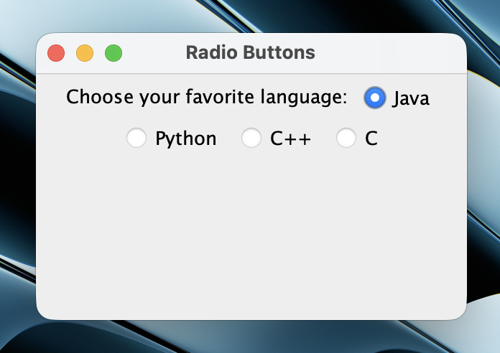

**Question:** Program to display "All The Best" in 5 different colors on screen.

**Solution:**

import javax.swing.*;

import java.awt.*;

public class AllTheBestColors extends JFrame {

public AllTheBestColors() {

setTitle("All The Best in Colors");

setSize(400, 300);

setDefaultCloseOperation(JFrame.EXIT_ON_CLOSE);

}

public void paint(Graphics g) {

super.paint(g);

String text = "All The Best";

Color[] colors = { Color.RED, Color.BLUE, Color.GREEN, Color.ORANGE, Color.MAGENTA };

int y = 80;

for (Color c : colors) {

g.setColor(c);

g.setFont(new Font("Arial", Font.BOLD, 24));

g.drawString(text, 100, y);

y += 40;

}

}

public static void main(String[] args) {

new AllTheBestColors().setVisible(true);

}

}

**Output:**



**Day 13: Homework**

**Question:** Program to implement handling in a button "OK".

**Solution:**

import javax.swing.*;

import java.awt.event.*;

public class OKButtonHandler {

public static void main(String[] args) {

JFrame frame = new JFrame("Button Handler");

frame.setDefaultCloseOperation(JFrame.EXIT_ON_CLOSE);

frame.setSize(300, 150);

JButton okButton = new JButton("OK");

okButton.addActionListener(e -> JOptionPane.showMessageDialog(frame, "OK Button Clicked!"));

frame.getContentPane().add(okButton);

frame.setVisible(true);

}

}

**Output:**

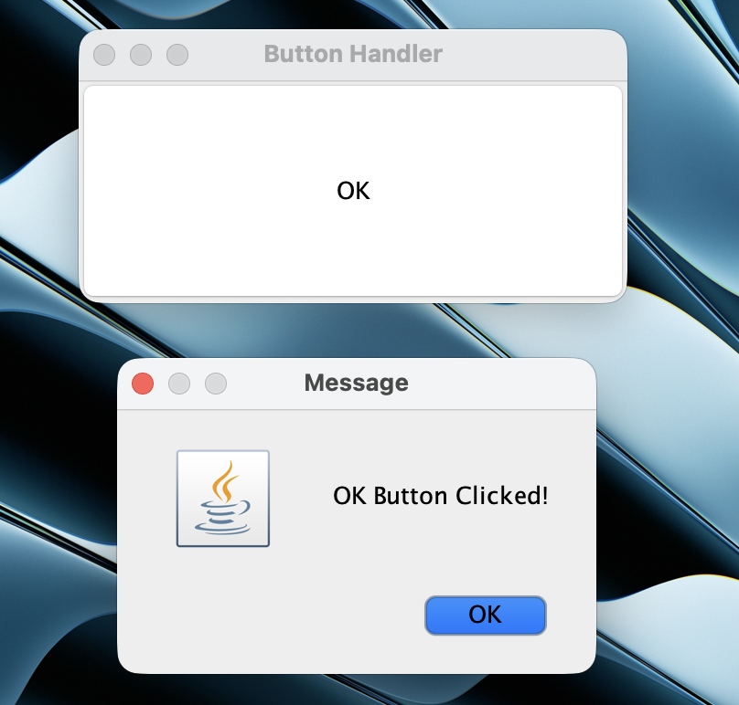

**Question:** Java Program to implement BorderLayout.

**Solution:**

import javax.swing.*;

import java.awt.*;

public class BorderLayoutDemo extends JFrame {

public BorderLayoutDemo() {

setTitle("Border Layout Demo");

setSize(400, 300);

setDefaultCloseOperation(JFrame.EXIT_ON_CLOSE);

setLayout(new BorderLayout());

add(new JButton("North"), BorderLayout.NORTH);

add(new JButton("South"), BorderLayout.SOUTH);

add(new JButton("East"), BorderLayout.EAST);

add(new JButton("West"), BorderLayout.WEST);

add(new JButton("Center"), BorderLayout.CENTER);

setVisible(true);

}

public static void main(String[] args) {

new BorderLayoutDemo();

}

}

**Output:**

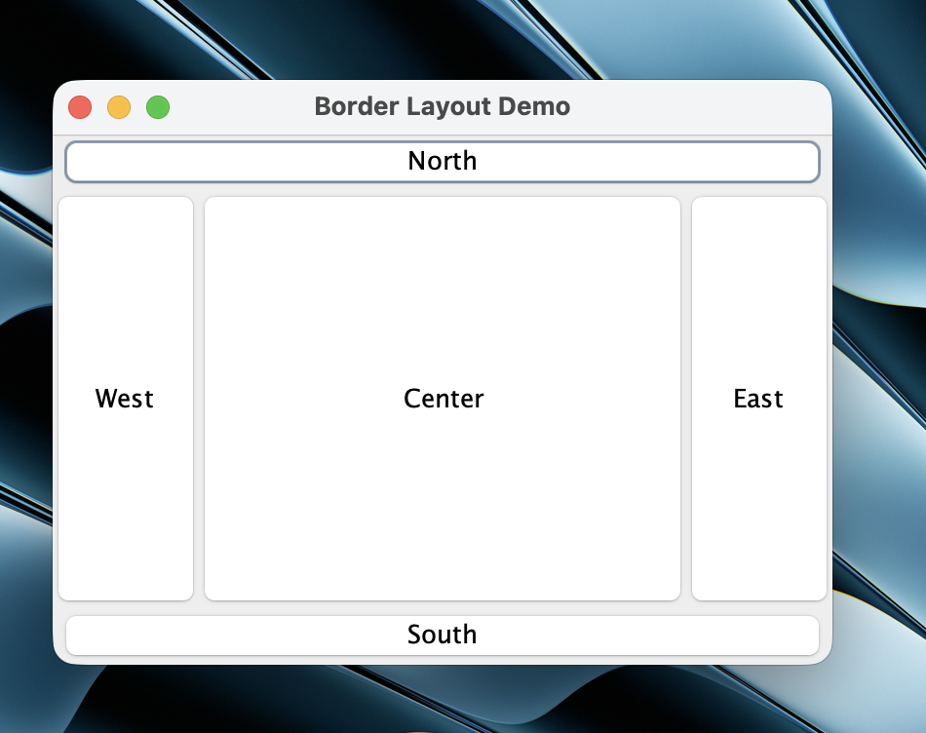

**Day 14: Classwork**

**Question:** Java Program to implement GridLayout.

**Solution:**

import javax.swing.*;

import java.awt.*;

public class GridLayoutExt {

public static void main(String[] args) {

JFrame frame = new JFrame("GridLayout");

frame.setDefaultCloseOperation(JFrame.EXIT_ON_CLOSE);

frame.setSize(300, 200);

frame.setLayout(new GridLayout(3, 2, 10, 10));

for (int i = 1; i <= 6; i++) {

frame.add(new JButton("Button " + i));

}

frame.setVisible(true);

}

}

**Output:**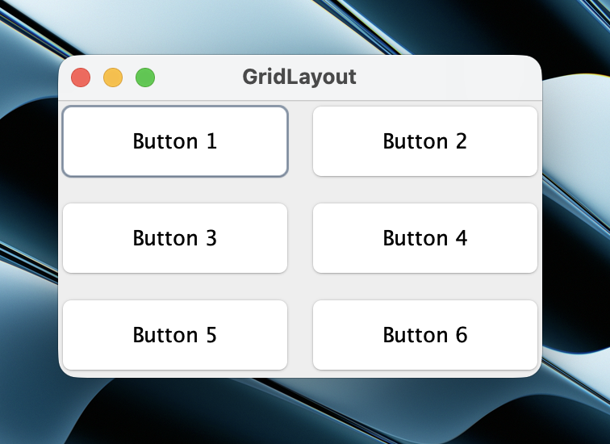

**Question:** Java Program to implement BoxLayout.

**Solution:**

import javax.swing.*;

import java.awt.*;

public class BoxLayoutEx {

public static void main(String[] args) {

JFrame frame = new JFrame("BoxLayout Demo");

frame.setDefaultCloseOperation(JFrame.EXIT_ON_CLOSE);

frame.setSize(300, 200);

JPanel panel = new JPanel();

panel.setLayout(new BoxLayout(panel, BoxLayout.Y_AXIS));

panel.add(new JButton("Button 1"));

panel.add(Box.createRigidArea(new Dimension(0, 10)));

panel.add(new JButton("Button 2"));

panel.add(Box.createRigidArea(new Dimension(0, 10)));

panel.add(new JButton("Button 3"));

frame.add(panel);

frame.setVisible(true);

}

}

**Output:**

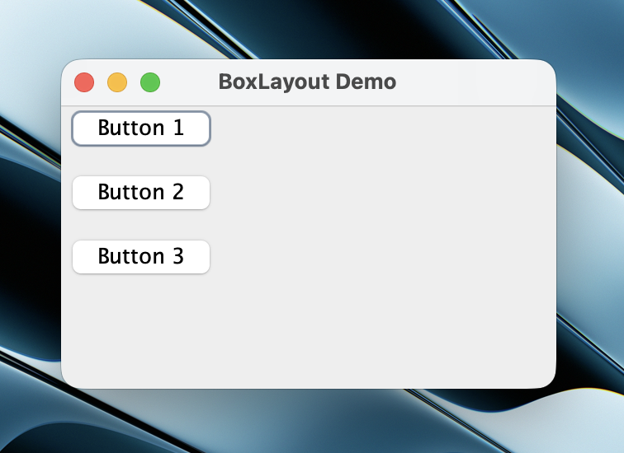

**Question:** Java Program to implement CardLayout.

**Solution:**

import javax.swing.*;

import java.awt.*;

public class CardLayoutEx {

public static void main(String[] args) {

JFrame frame = new JFrame("CardLayout Demo");

frame.setDefaultCloseOperation(JFrame.EXIT_ON_CLOSE);

frame.setSize(400, 200);

CardLayout cardLayout = new CardLayout();

JPanel cardPanel = new JPanel(cardLayout);

cardPanel.add(new JLabel("This is Card One", SwingConstants.CENTER), "Card 1");

cardPanel.add(new JLabel("This is Card Two", SwingConstants.CENTER), "Card 2");

JPanel buttonPanel = new JPanel();

JButton btn1 = new JButton("Show Card 1");

JButton btn2 = new JButton("Show Card 2");

buttonPanel.add(btn1);

buttonPanel.add(btn2);

btn1.addActionListener(e -> cardLayout.show(cardPanel, "Card 1"));

btn2.addActionListener(e -> cardLayout.show(cardPanel, "Card 2"));

frame.add(cardPanel, BorderLayout.CENTER);

frame.add(buttonPanel, BorderLayout.SOUTH);

frame.setVisible(true);

}

}

**Output:**

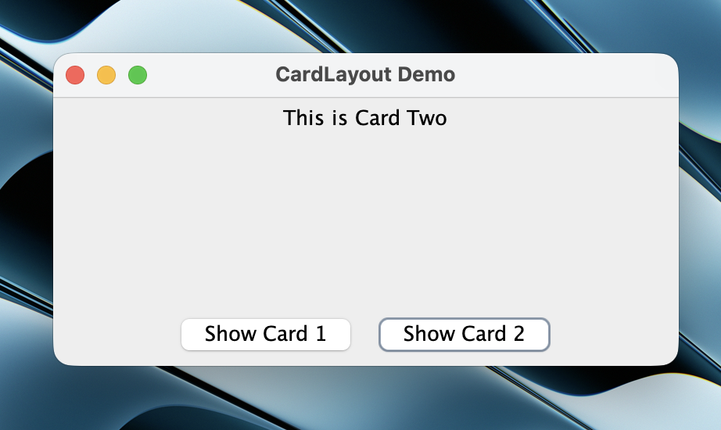

**Question:** Java program to implement Generic class.

**Solution:**

class Box<T> {

private T item;

public void setItem(T item) { this.item = item; }

public T getItem() { return item; }

}

public class GenricClassDemo {

public static void main(String[] args) {

Box<Integer> integerBox = new Box<>();

integerBox.setItem(123);

System.out.println("Integer value: " + integerBox.getItem());

Box<String> stringBox = new Box<>();

stringBox.setItem("Hello Generics");

System.out.println("String value: " + stringBox.getItem());

}

}

**Output:**

/Users/kunwarshauryapratapsingh/Desktop/OOTSWorkshop/out/production/ClassworkDay14/GenricClassDemo

Integer value: 123

String value: Hello Generics

Process finished with exit code 0

**Day 14: Homework**

**Question:** Java program to illustrate Generic methods.

**Solution:**

public class GenericMethodDemo {

public static <E> void printArray(E[] inputArray) {

for (E element : inputArray) {

System.out.print(element + " ");

}

System.out.println();

}

public static void main(String[] args) {

Integer[] intArray = { 1, 2, 3, 4, 5 };

Double[] doubleArray = { 1.1, 2.2, 3.3, 4.4 };

String[] stringArray = { "Hello", "World" };

System.out.print("Integer Array: ");

printArray(intArray);

System.out.print("Double Array: ");

printArray(doubleArray);

System.out.print("String Array: ");

printArray(stringArray);

}

}

**Output:**

/Users/kunwarshauryapratapsingh/Desktop/OOTSWorkshop/out/production/HomeworkDay14/GenericMethodDemo

Integer Array: 1 2 3 4 5

Double Array: 1.1 2.2 3.3 4.4

String Array: Hello World

Process finished with exit code 0

**Question:** Java program to implement wildcard in generics.

**Solution:**

import java.util.Arrays;

import java.util.List;

public class WildCardDem {

public static double sumOfList(List<? extends Number> list) {

double sum = 0.0;

for (Number n : list) {

sum += n.doubleValue();

}

return sum;

}

public static void main(String[] args) {

List<Integer> intList = Arrays.asList(1, 2, 3, 4);

System.out.println("Sum of integers = " + sumOfList(intList));

List<Double> doubleList = Arrays.asList(1.1, 2.2, 3.3);

System.out.println("Sum of doubles = " + sumOfList(doubleList));

}

}

**Output:**

/Users/kunwarshauryapratapsingh/Desktop/OOTSWorkshop/out/production/HomeworkDay14/WildCardDem

Sum of integers = 10.0

Sum of doubles = 6.6

Process finished with exit code 0

**Day 16: Classwork**

**Question:** Java program to implement methods of HashSet.

**Solution:**

import java.util.HashSet;

public class HashSetEx {

public static void main(String[] args) {

HashSet<String> set = new HashSet<>();

set.add("Apple");

set.add("Banana");

set.add("Cherry");

set.add("Apple"); // Duplicate, will be ignored

System.out.println("HashSet: " + set);

System.out.println("Contains 'Banana'? " + set.contains("Banana"));

set.remove("Apple");

System.out.println("After removing 'Apple': " + set);

}

}

**Output:**

/Users/kunwarshauryapratapsingh/Desktop/OOTSWorkshop/out/production/ClassWorkDay16/HashSetEx

HashSet: [Apple, Cherry, Banana]

Contains 'Banana'? true

After removing 'Apple': [Cherry, Banana]

Process finished with exit code 0

**Question:** Java Program to implement methods available in HashMap class.

**Solution:**

import java.util.HashMap;

public class HashMapDemo {

public static void main(String[] args) {

HashMap<String, Integer> map = new HashMap<>();

map.put("Anamika", 25);

map.put("Rohit", 30);

map.put("Kunal", 35);

System.out.println("HashMap: " + map);

System.out.println("Rohit's age: " + map.get("Rohit"));

map.remove("Anamika");

System.out.println("After removing Anamika: " + map);

}

}

**Output:**

/Users/kunwarshauryapratapsingh/Desktop/OOTSWorkshop/out/production/ClassWorkDay16/HashMapDemo

HashMap: {Anamika=25, Rohit=30, Kunal=35}

Rohit's age: 30

After removing Anamika: {Rohit=30, Kunal=35}

Process finished with exit code 0

**Question:** Program to add, retrieve, and remove element from ArrayList.

**Solution:**

import java.util.ArrayList;

public class ArrayListDemo {

public static void main(String[] args) {

ArrayList<String> list = new ArrayList<>();

list.add("First");

list.add("Second");

list.add("Third");

System.out.println("Initial ArrayList: " + list);

String secondElement = list.get(1);

System.out.println("Element at index 1: " + secondElement);

list.remove(0);

System.out.println("After removing element at index 0: " + list);

}

}

**Output:**

/Users/kunwarshauryapratapsingh/Desktop/OOTSWorkshop/out/production/ClassWorkDay16/ArrayListDemo

Initial ArrayList: [First, Second, Third]

Element at index 1: Second

After removing element at index 0: [Second, Third]

Process finished with exit code 0

**Question:** Create a method which can accept a collection of country names and add it to ArrayList.

**Solution:**

import java.util.*;

public class CountryList {

public static ArrayList<String> createCountryList(Collection<String> countries) {

return new ArrayList<>(countries);

}

public static void main(String[] args) {

List<String> countryNamesList = Arrays.asList("India", "USA", "UK");

System.out.println("Created from List: " + createCountryList(countryNamesList));

}

}

**Output:**

/Users/kunwarshauryapratapsingh/Desktop/OOTSWorkshop/out/production/ClassWorkDay16/CountryList

Created from List: [India, USA, UK]

Process finished with exit code 0

**Question:** Create a method which can create a HashSet containing values 1-10.

**Solution:**

import java.util.HashSet;

public class hashSetDEmo {

public static HashSet<Integer> createIntegerSet() {

HashSet<Integer> set = new HashSet<>();

for (int i = 1; i <= 10; i++) {

set.add(i);

}

return set;

}

public static void main(String[] args) {

System.out.println("HashSet with numbers 1-10: " + createIntegerSet());

}

}

**Output:**

/Users/kunwarshauryapratapsingh/Desktop/OOTSWorkshop/out/production/ClassWorkDay16/hashSetDEmo

HashSet with numbers 1-10: [1, 2, 3, 4, 5, 6, 7, 8, 9, 10]

Process finished with exit code 0

**Day 16: Homework**

**Question:** Java program to implement autoboxing and unboxing.

**Solution:**

public class AutoboxingANDunboxing {

public static void main(String[] args) {

// Autoboxing

int primitiveInt = 100;

Integer wrapperInt = primitiveInt;

System.out.println("Autoboxing: primitive " + primitiveInt + " -> wrapper " + wrapperInt);

// Unboxing

Integer anotherWrapper = Integer.valueOf(200);

int anotherPrimitive = anotherWrapper;

System.out.println("Unboxing: wrapper " + anotherWrapper + " -> primitive " + anotherPrimitive);

}

}

**Output:**

/Users/kunwarshauryapratapsingh/Desktop/OOTSWorkshop/out/production/HomeWorkDay16/AutoboxingANDunboxing

Autoboxing: primitive 100 -> wrapper 100

Unboxing: wrapper 200 -> primitive 200

Process finished with exit code 0

**Question:** Develop a java class with a method storeEvenNumbers(int N) using ArrayList.

**Solution:**

import java.util.ArrayList;

public class EvenNumStorage {

public ArrayList<Integer> storeEvenNumbers(int N) {

ArrayList<Integer> A1 = new ArrayList<>();

for (int i = 2; i <= N; i += 2) {

A1.add(i);

}

return A1;

}

public static void main(String[] args) {

EvenNumStorage ens = new EvenNumStorage();

ArrayList<Integer> evenNumbers = ens.storeEvenNumbers(30);

System.out.println("Even numbers from 2 to 30: " + evenNumbers);

}

}

**Output:**

/Users/kunwarshauryapratapsingh/Desktop/OOTSWorkshop/out/production/HomeWorkDay16/EvenNumStorage

Even numbers from 2 to 30: [2, 4, 6, 8, 10, 12, 14, 16, 18, 20, 22, 24, 26, 28, 30]

Process finished with exit code 0

**Question:** Create a method that accepts the names of five countries and loads them to an array list.

**Solution:**

import java.util.ArrayList;

public class FiveCountries {

public ArrayList<String> createList(String c1, String c2, String c3, String c4, String c5) {

ArrayList<String> list = new ArrayList<>();

list.add(c1); list.add(c2); list.add(c3); list.add(c4); list.add(c5);

return list;

}

public static void main(String[] args) {

FiveCountries fc = new FiveCountries();

ArrayList<String> countryList = fc.createList("India", "Germany", "Brazil", "Egypt", "Spain");

System.out.println("List of five countries: " + countryList);

}

}

**Output:**

/Users/kunwarshauryapratapsingh/Desktop/OOTSWorkshop/out/production/HomeWorkDay16/FiveCountries

List of five countries: [India, Germany, Brazil, Egypt, Spain]

Process finished with exit code 0

**Question:** Create a method which can accept a collection of country names and add it to ArrayList with generic defined as String and return the list.

**Solution:**

import java.util.*;

public class CountryListCollection {

public static ArrayList<String> createCountryList(Collection<String> countries) {

return new ArrayList<>(countries);

}

public static void main(String[] args) {

List<String> countryList = Arrays.asList("India", "USA", "UK");

System.out.println("ArrayList from List: " + createCountryList(countryList));

Set<String> countrySet = new HashSet<>(Arrays.asList("Canada", "Australia"));

System.out.println("ArrayList from Set: " + createCountryList(countrySet));

}

}

**Output:**

/Users/kunwarshauryapratapsingh/Desktop/OOTSWorkshop/out/production/HomeWorkDay16/CountryListCollection

ArrayList from List: [India, USA, UK]

ArrayList from Set: [Canada, Australia]

Process finished with exit code 0